

Name : Adil Khan
Roll No : 2330-0030
Dept: BS AI
Subject: Data Base system

Lab Task:
CREATE DATABASE CompanyDB;
USE CompanyDB;
CREATE TABLE employees (
EmpID INT PRIMARY KEY,
Name VARCHAR(50),
Department VARCHAR(50),
Salary DECIMAL(10,2),
Age INT, City VARCHAR(50),
Joining_Date DATE
);

INSERT INTO employees VALUES
(101, 'Ahmed Raza', 'HR', 55000, 28, 'Lahore', '2020-01-15'),
(102, 'Sana Tariq', 'Finance', 72000, 32, 'Karachi', '2019-03-20'),
(103, 'Bilal Ahmed', 'IT', 90000, 30, 'Islamabad', '2021-06-11'),
(104, 'Arif Khan', 'Marketing', 65000, 27, 'Faisalabad', '2020-09-09'),
(105, 'Sara Malik', 'IT', 85000, 29, 'Lahore', '2022-02-17'),
(106, 'Usman Ali', 'HR', 48000, 26, 'Multan', '2021-04-05'),
(107, 'Fatima Noor', 'Finance', 75000, 33, 'Karachi', '2018-12-25'),
(108, 'Shahid Mehmood', 'Marketing', 62000, 31, 'Lahore', '2019-07-13'),
(109, 'Ayesha Rehman', 'IT', 97000, 34, 'Islamabad', '2017-08-10'),
(110, 'Saad Anwar', 'HR', 50000, 25, 'Lahore', '2023-01-05');

Task no 1:
SELECT *FROM employees
WHERE Age <30;
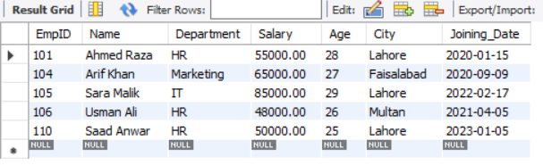

Task no 2:
SELECT *FROM employees
WHERE salary BETWEEN 60000 and 90000;

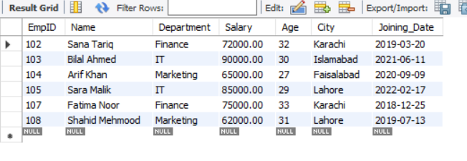

Task no 3:
SELECT *FROM employees
WHERE City IN ('Lahore','Islamabad');

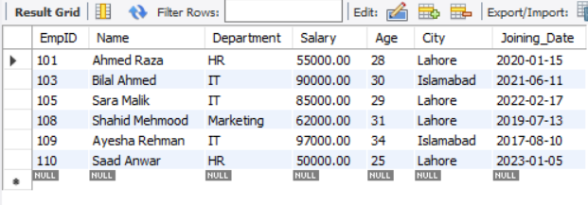

Task no 4:
SELECT *FROM employees
WHERE name LIKE 'A%';

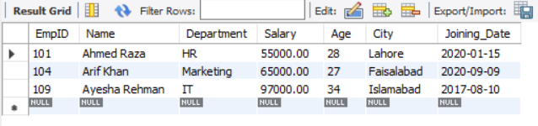
Task no 5:
SELECT *FROM employees
WHERE name LIKE '%Sa%';

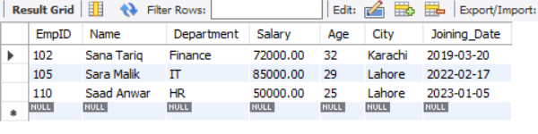

Task no 6:
SELECT *FROM employees
WHERE Department='IT' AND Salary>80000;

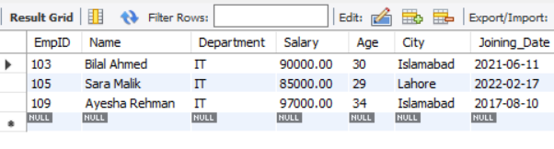

Task no 7:
SELECT *FROM employees
WHERE city<> 'Karachi' AND joining_date> '2020-12-07';

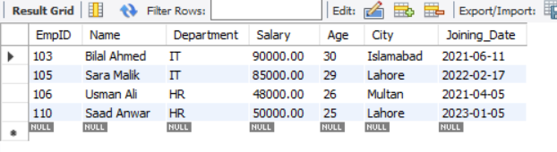

Task no 8:
SELECT *FROM employees
WHERE (Department='HR' OR Department='Marketing')
AND (Salary BETWEEN 50000 AND 80000)
AND Name LIKE '%a%';

